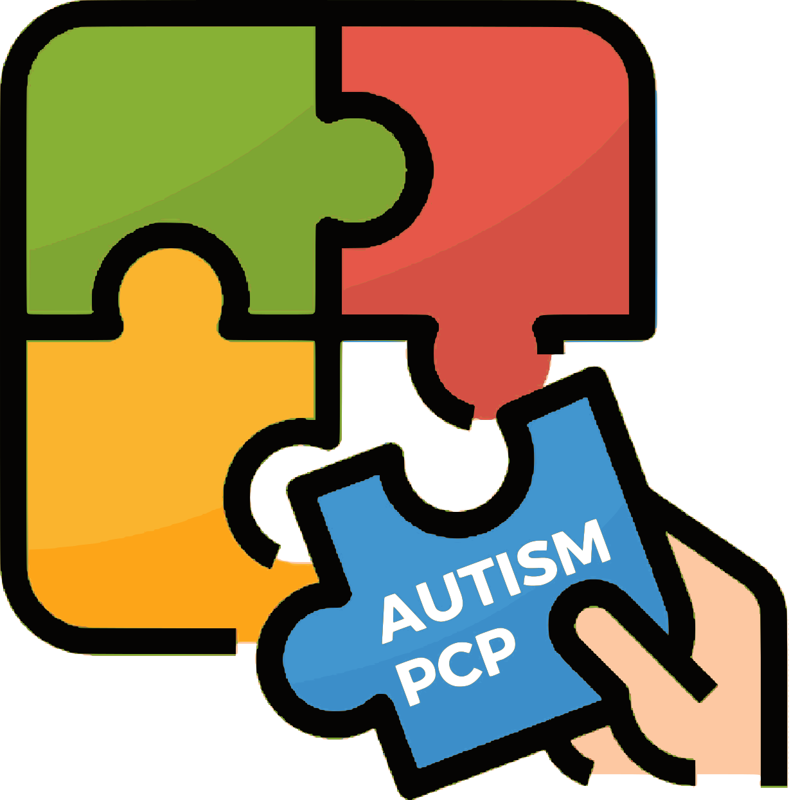
AUTISM_PCP

IO2 – Tools/guidelines for facilitators

Desk research template
To be filled in by all partners

Introduction
Dear partners,
In this template you are presented with the title of the respective section of the final publication, some objective and questions to be answered in each fields and a blank space to fill in your contributions.
Please try to provide your resources when possible in order to be included in the bibliography.
The fields represent the sections for the chapters 4,5,6 and 7 of the final publication.
You do not need to make your own final texts, but it would be nice to provide complete information, well justified when possible. In case you want to propose texts taken from other publications, always indicate the page on the publication where the text is found. But you can definitely base your answers also on your practical experience.

Questions to be answered

Chapter 4: Guidelines for educators as facilitators

a) Educator vs facilitator
Objectives: Try to define/locate the differences between an educator teaching neurotypical persons and an educator teaching neurodiverse (in our case autistic) persons.
- What are the differences?
- What are the more specific needs (in terms of training, resources, etc)?
… any other relevant information
Add your answer here

Add your resources here

b) Dealing with short term transitions
Objectives: Through the bibliographical research, try to find challenges faced by the educators when dealing with short term transitions for an autistic student, practices implemented that have been successful, school policies implemented to assist with that (if possible)
- Most common issues to deal with
- Are there good practices implemented by the educators? (mention also place)
- Are there policies taken by the school/learning institution? (mention them if possible)
… any other relevant information
Add your answer here

Add your resources here

c) Dealing with long term transitions
Objectives: Through the bibliographical research, try to find challenges faced by the educators when dealing with long term transitions for an autistic student, practices implemented that have been successful, school policies implemented to assist with that (if possible)
- Most common issues to deal with
- Are there good practices implemented by the educators? (mention also place)
- Are there policies taken by the school/learning institution? (mention them if possible)
… any other relevant information
Add your answer here

Add your resources here

e) Additional guidelines
Objectives: Here you can add relevant information and experience of educators of autistic people that could be helpful generally, not specifically for the transition situations.
[optional]
Add your answer here

Add your resources here

Chapter 5: Guidelines for educators as trainers/mentors/coaches

a) Trainer/mentor/coach vs facilitator
Objectives: Try to define/locate the differences between a trainer/mentor/coach working with neurotypical persons and a trainer/mentor/coach working with neurodiverse (in our case autistic) persons.
- What are the differences?
- What are the more specific needs (in terms of training, resources, etc)?
… any other relevant information
Add your answer here

Add your resources here

b) Dealing with short term transitions
Objectives: Through the bibliographical research, try to find challenges faced by the trainers/mentors/coaches when dealing with short term transitions for an autistic trainee/mentee/coachee, practices implemented that have been successful, policies implemented to assist with that (if possible)
- Most common issues to deal with
- Are there good practices implemented by the educators? (mention also place)
- Are there policies taken by the training/mentoring/coaching institution? (mention them if possible)
… any other relevant information
Add your answer here

Add your resources here

c) Dealing with long term transitions
Objectives: Through the bibliographical research, try to find challenges faced by the trainers/mentors/coaches when dealing with long term transitions for an autistic trainee/mentee/coachee, practices implemented that have been successful, policies implemented to assist with that (if possible)
- Most common issues to deal with
- Are there good practices implemented by the educators? (mention also place)
- Are there policies taken by the training/mentoring/coaching institution? (mention them if possible)
… any other relevant information
Add your answer here

Add your resources here

e) Additional guidelines
Objectives: Here you can add relevant information and experience of trainers/mentors/coaches of autistic people that could be helpful generally, not specifically for the transition situations.
[optional]
Add your answer here

Add your resources here

Chapter 6: Guidelines for support circle

a) The specific nature of the support circle
Objectives: Try to define the importance, the need and the characteristics of the support circle
- What is the support circle?
- How do you make it effective?
- What do you need to know when belonging to the support circle of an autistic person?
… any other relevant information
Add your answer here

Add your resources here

b) Dealing with short term transitions
Objectives: Through the bibliographical research, try to find challenges faced by the support circle when dealing with short term transitions for an autistic person, practices implemented that have been successful, any other relevant information
- Most common issues to deal with
- Are there good practices implemented by the support circle? (mention also place)
… any other relevant information
Add your answer here

Add your resources here

c) Dealing with long term transitions
Objectives: Through the bibliographical research, try to find challenges faced by the support circle when dealing with long term transitions for an autistic person, practices implemented that have been successful, any other relevant information
- Most common issues to deal with
- Are there good practices implemented by the support circle? (mention also place)
… any other relevant information
Add your answer here

Add your resources here

e) Additional guidelines
Objectives: Here you can add relevant information and experience of the support circle of autistic people that could be helpful generally, not specifically for the transition situations.
[optional]
Add your answer here

Add your resources here

Chapter 7: Additional guidelines for everyone

a) Psychological support
Objectives:
- Psychology: basic terms and concepts that are common in autism and autism related environments
- Understanding the psychological nature of the interventions and how to more appropriately approach the autistic person
- Cultivating acceptance and understanding???
… any other relevant information
Add your answer here

Add your resources here

b) Pedagogical support
Objectives:
- Pedagogy: basic terms, concepts and approaches that are either common in autism and autism related environments or could be implemented in these circumstances due to their approach
- Understanding the specific pedagogical needs and which are better to be used when approaching the autistic person in assisting with the transitions
… any other relevant information
Add your answer here

Add your resources here

c) Good communication with relevant parties
Objectives: How to communicate needs, knowledge, experience among the support circle, the external professionals, friends, community, etc
- Structuring and keeping important information
- Asking for help
- Advocating for autism acceptance and support for the autistic/neurodiverse people / Raising awareness
… any other relevant information
Add your answer here

Add your resources here

d) Dealing with bullying/judgement
Objectives:
- Dealing with bullying targeted towards the autistic person
- Dealing with judgement targeted towards the autistic persons’ environment
- Fighting social stigma/exclusion
… any other relevant information
Add your answer here

Add your resources here

e) Keeping a balanced mindset
Objectives:
- Understanding the importance of sharing obligations
- Taking time to relax and recharge your “batteries”
- Maintaining relationships and belonging to the community
… any other relevant information
Add your answer here

Add your resources here

